PROGRAMMABLE LOAD SHEDDING TIME MANAGEMENT FOR UTILITY DEPARTMENT
ABSTRACT

The project is designed to operate an electrical load multiple number of times as per the program. It overcomes the difficulties of switching the load ON/OFF manually. This proposed has an inbuilt real time clock (RTC) to keep tracking the time and thus to switch ON/OFF the load accordingly.
Load shedding is what electric utilities do when there is a huge demand for electricity that exceeds the supply. Thus in a distribution system it needs to be precisely controlled for specific period of time. Programmable load shedding time management system is a reliable circuit that takes over the manual task of switch ON/OFF the electrical devices with respect to time. It uses real time clock (RTC) interfaced to a microcontroller of PIC family. While the set time equals to the real time, then microcontroller gives command to the corresponding relay to turn ON the load and then another command to switch OFF as per the program. Multiple ON/OFF time entry is the biggest advantage with this project. A matrix keypad helps entering the time. A 7-sement display is interfaced to the microcontroller to display time.
Further the project can be enhanced by interfacing a GSM modem to the existing project so that the complete control of the load can be done by sending an SMS to the control unit.

BLOCK DIAGRAM

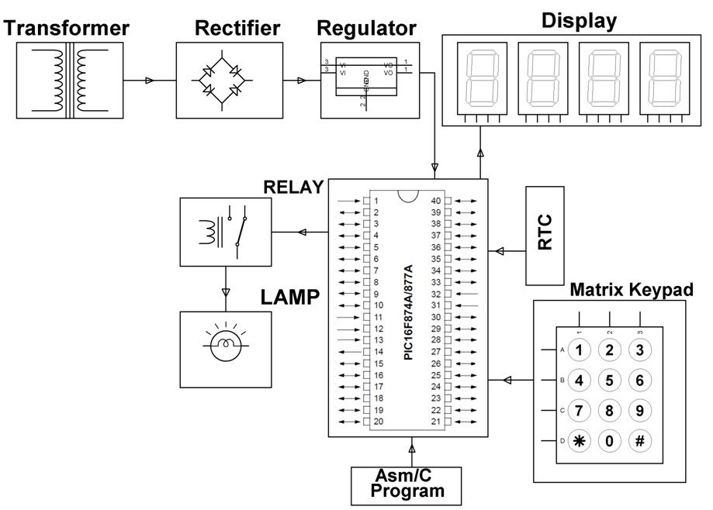

HARDWARE REQUIREMENTS:
PIC series Microcontroller, 7-Segment Display, RTC, Keypad, Relay, Relay Driver IC, LED, Crystal, Transformer, Diodes, Regulator, Capacitors, Resistors, Lamp.

SOFTWARE REQUIREMENTS:

HI-TECH PICC Tool suite

Language: Embedded C or Assembly

